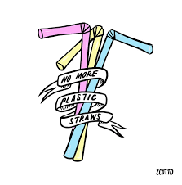

Think that plastic straws don’t harm the air? Wrong!

Here are the Top 3 reasons why

Plastic Straws Pollute the Air:

Reason 1: When plastic straws are made, we have to use fossil fuels, which contributes to global warming. Also, when we burn plastic straws, it creates smoke very similar to the smoke a factory would make, which is polluting the air.

Reason 2: Plastic straws crowd landfills and we are running out of space! Also, they don’t even belong in them because they take way too long to decompose (200 years!) When they do decompose, they release methane, a greenhouse gas which contributes to global warming.

Reason 3: We breathe the air, so air pollution is bad for our health and our planet. This is all catastrophic for humans.